In LKS2, children with consistent letter formation are taught to join by understanding horizontal and diagonal joins.

Content will include:

* Horizontal and diagonal joins
* Capital letters not joining to lower case letters.
* Developing a legible, joined handwriting style.
* Using joined-up handwriting the majority of the time.

Children in Year 4 who are more confident with joined writing will focus on:

* Maintaining legibility while writing fluently and with increasing speed.
* Writing words and sentences maintaining clear joins

The weekly scheme may be adapted to challenge confident joiners, whilst giving them chance to consolidate their learning.

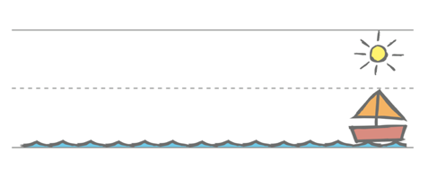

Children will have handwriting modelled to them using the RWI template. It focuses on visual prompts of the sun, boat to teach joins.

|  |  |  |
| --- | --- | --- |
| **LKS2** | | |
| Term 1 | 1- around letters not joined (smaller lines in books)  2- down letters not joined (smaller lines in books)  3- curly letters not joined (smaller lines in books)  4- zig zag letters (smaller lines in books)  5- Break letters not joining **g j y f b p x z** **s**  6- arm to boat **a c d e**  7- arm to boat **k h I**  8- arm to boat **m n t u**  10 consolidate joins and break letters | |
| Term 2 | 1- arm to sun **at ab (curly to a**  2- arm to sun  3- arm to sun  4- arm to sister  5- arm to sister  6- introduce washing line joins **vi vu ri re**  7- washing line to boat with droop **wi wr vu**  8- washing line to sister joins  9- washing line to sister joins  10- consolidation | |
| Term 3 | Year 3  1- washing line to boat  2-washing line to sun  3- washing line to sun  4- parallel ascenders  5-joining an s  6-spacing between words  7-spacing letters and words  8- revising break letters  9- presentation  10- presentation | Year 4  1- joining g y j  2- joining p b  3- consolidation g y j p b  5-joining an s  6-spacing between words  7-spacing letters and words  8- revising break letters  9- presentation  10- presentation |